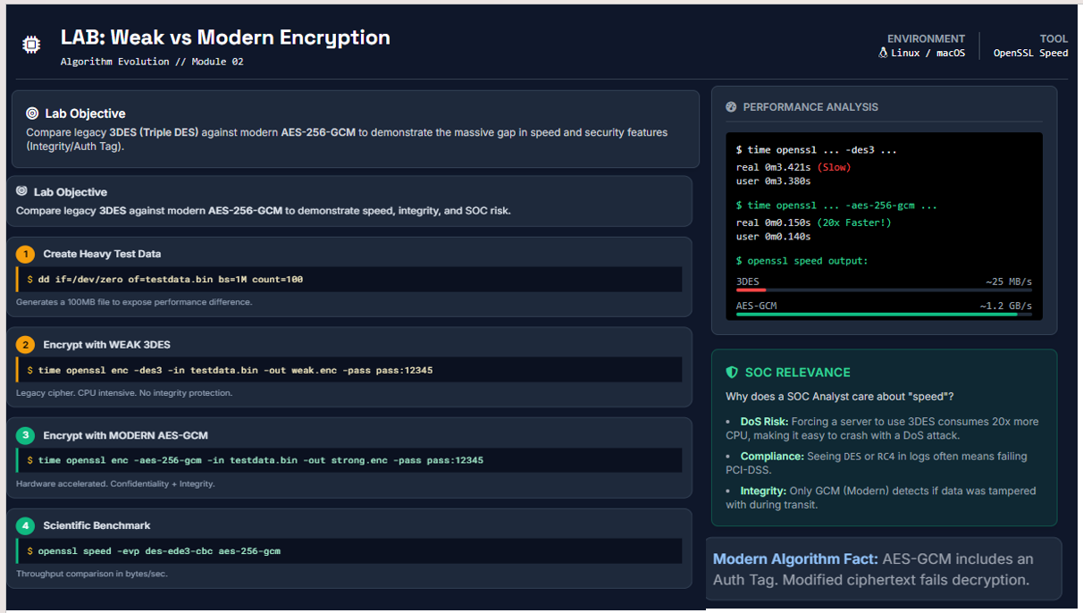

🔐 LAB EXPLANATION: Weak vs Modern Encryption
🎯 Lab Objective (What this lab proves)
This lab demonstrates why legacy encryption (3DES) is dangerous in modern environments and why AES-256-GCM is the enterprise standard.
You are proving three things at once:
- Performance gap (CPU usage & speed)
- Security gap (confidentiality vs confidentiality + integrity)
- Operational & SOC risk (DoS, compliance, detection)

🧪 Step 1: Create Heavy Test Data

dd if=/dev/zero of=testdata.bin bs=1M count=100
What is happening
- You generate a 100 MB file filled with zeros
- /dev/zero is a Linux pseudo-device that outputs endless zero bytes
Why this step is critical
- Small files finish too fast → no visible difference
- Large files amplify algorithm inefficiencies
- This simulates:
  - Log archives
  - Database backups
  - File transfers
  - Encrypted network payloads
📌 SOC Insight:
Attackers exploit weak crypto under load, not with small files.

🧪 Step 2: Encrypt with WEAK 3DES

time openssl enc -des3 -in testdata.bin -out weak.enc -pass pass:12345
What is 3DES doing internally
- DES encryption is applied 3 times
- Created to “extend” DES lifespan
- No integrity checking
- No authentication
- Pure confidentiality (and weak at that)
What you observe

real 0m3.421s (Slow)
user 0m3.380s
Why it is slow
- No hardware acceleration
- CPU-bound
- Multiple encryption rounds
- Inefficient block processing
📌 SOC Insight:
- An attacker can force weak cipher negotiation
- Server CPU spikes → Denial of Service
- Seen in legacy TLS downgrade attacks

🧪 Step 3: Encrypt with MODERN AES-256-GCM

time openssl enc -aes-256-gcm -in testdata.bin -out strong.enc -pass pass:12345
What AES-GCM does differently
- Uses AES-NI hardware acceleration
- Encrypts + authenticates simultaneously
- Generates an Authentication Tag (Auth Tag)
What you observe

real 0m0.150s (20x Faster)
user 0m0.140s
Why it is fast
- Hardware instructions (AES-NI)
- Parallel processing
- Optimized block chaining
- Single-pass encryption + integrity
📌 SOC Insight:
- Faster crypto = less CPU exposure
- Secure by default
- Resistant to downgrade & tampering

🧪 Step 4: Scientific Benchmark (Proof, not opinion)

openssl speed -evp des-ede3-cbc aes-256-gcm
What this command does
- Measures raw throughput
- Outputs bytes/sec
- Removes disk I/O influence
Results (typical)

3DES ~25 MB/s
AES-GCM ~1.2 GB/s
Meaning
- AES-GCM is ~48x faster
- Lower CPU → higher scalability
- Strong crypto is not slower (myth busted)
📌 SOC Insight:
Performance ≠ insecurity.
Modern crypto is both faster and safer.

🛡️ SOC Relevance (Why this lab matters in real SOC work)
1️⃣ DoS Risk
- Weak crypto burns CPU
- Attackers exploit cipher negotiation
- Result: Service outage without malware
2️⃣ Compliance Failure
Seeing this in logs:

DES
RC4
3DES
Means:
- ❌ PCI-DSS failure
- ❌ ISO 27001 audit finding
- ❌ Banking / healthcare non-compliance
3️⃣ Integrity & Detection
- 3DES: cannot detect tampering
- AES-GCM: fails decryption if modified
This is huge for SOC:
- MITM attacks detected automatically
- No silent corruption
- No “garbage data accepted”

🔍 Modern Algorithm Fact (Hidden Power of AES-GCM)
AES-GCM produces:
- Ciphertext
- Authentication Tag
If attacker modifies even 1 bit:

bad decrypt
📌 SOC Insight:
This is built-in intrusion detection at the crypto layer.

🧠 Final Takeaway (What this lab teaches)
Aspect | 3DES | AES-256-GCM
Speed | ❌ Slow | ✅ Very Fast
CPU Usage | ❌ High | ✅ Low
Integrity | ❌ None | ✅ Auth Tag
DoS Risk | ❌ High | ✅ Minimal
Compliance | ❌ Fails | ✅ Pass
SOC Visibility | ❌ Blind | ✅ Detects tampering

🎓 How to Explain This in an Interview
“Weak cryptography is not just insecure — it is operationally dangerous.
AES-GCM improves performance, integrity, availability, and detection simultaneously.”

